**RESUME**

ANMOL JAIN

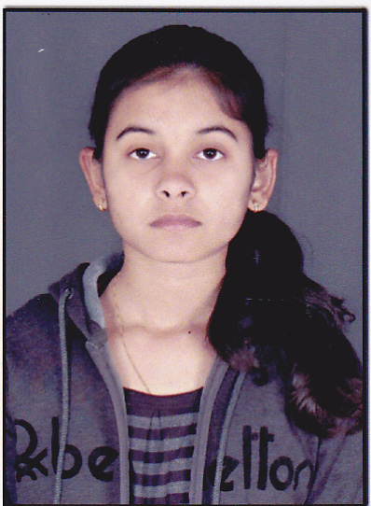

5, New Market

Zawar Mines, Udaipur 313901

9950944215

[anmol1994jain@gmail.com](mailto:anmol1994jain@gmail.com)

Career Objective:

To work for an organisation which provides me the opportunity to improve my skills and knowledge to grow along with the organisation’s objective.

Academic Qualification:

|  |  |  |  |  |
| --- | --- | --- | --- | --- |
| Qualification | Board/  University | College/  School | Year of Passing | Aggregate/  CGPA |
| B.tech | RTU | GITS Udaipur | 2016 | 80.0* |
| 10th | CBSE | K.V.Z.M. | 2010 | 9.4(CGPA) |
| 12th | CBSE | K.V.Z.M. | 2012 | 82.0 |

*\*Aggregate of 6 semesters*

Technical Skills:

|  |  |  |  |  |  |  |
| --- | --- | --- | --- | --- | --- | --- |
| |  |  | | --- | --- | | Languages known: | C, C++, PHP, Java(core) | | Operating System: | Windows XP, Windows 7, 8 | | IDE: | Adobe Dreamweaver CS6, NetBeans IDE 8.0.1 |   Projects:   * Developed a project on “Rajasthan Tourism” using PHP language * Developed a project on “Library Management System” using Java language |
| Achievements and Extra Curricular Activities:   * Secured a Merit Rank of 950 in 10th National IT Aptitude Test * Successfully completed Oracle Certification for Java(Core) * Appreciated for getting 2nd position in 2nd year * Position holder for Calligraphy, Poem Recitation etc. at school level   Interests and Hobbies:  Listening to music, Drawing, Reading newspaper  Personal Information:  Father’s Name : Raj Kumar Jain  Date of Birth : 20/07/1994  Languages known : Hindi, English  Nationality : Indian  Gender : Female  Marital Status : Single  Declaration:  I, hereby declare that the information given above is correct to the best of my knowledge.  **Place:** **ANMOL JAIN**  **Date:** |